ECOLOGY TEST
1. Which of the following would most likely happen if grasses and shrubs were removed from a rural Massachusetts ecosystem?

- There would be an increase in consumers in the ecosystem.
- There would be an increase of photosynthesis in the ecosystem.
- There would be a decrease in energy produced by the ecosystem.
- There would be a decrease of carbon dioxide available to the ecosystem.

2. A food web is shown below.
In this food web, the trophic level with the least energy includes which of the following organisms?
A. grasses
B. mice
C. snakes
D. hawks

3. When succession occurs in areas where previous growth has occurred, it is called
A. primary succession B. secondary succession
C. natural selection
D. pioneer succession

4. Which of the following is the best example of primary succession?
A. flood mosses shrubs hemlock trees
B. abandoned farm grasses exposed rock high-order carnivores
C. exposed rock mosses grasses herbivores
D. forest fire lichens bushes deer

5. The diagrams below show a marine food web and an incomplete terrestrial food web.
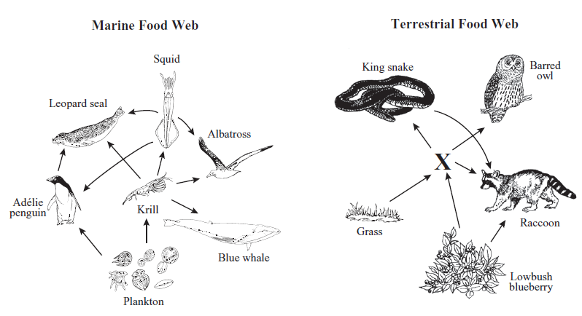
The organism in the terrestrial food web that corresponds to the krill in the marine food web is labeled X. Which of the following organisms is most likely organism X?
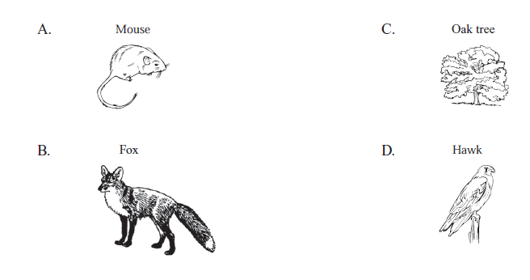
6. Some organisms cause decay by breaking down dead matter into raw nutrients. These organisms are best described as:
A. consumers
B. decomposers
C. producers
D. carnivores

7. A food web can be best described as:
A. a diagram that shows all different types of relationships animals can have with one another.
B. a chart showing how much energy is at the different trophic levels within an ecosystem.
C. an interconnected web of food chains.
D. a map containing different biomes.

8. Part of a tundra food web is shown below.
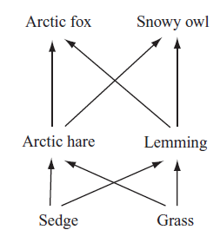

Which of the following describes the relationship between the sedge and the arctic hare?
A. competition
B. host-parasite
C. mutualism
D. producer-consumer

9. A graph of atmospheric carbon dioxide concentration over time is shown below.
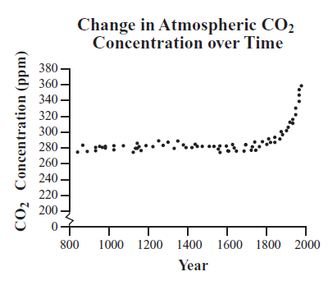
Scientists are investigating the cause of the large increase in atmospheric carbon dioxide concentration since about 1800. Which of the following provides the best explanation for the increase?
A. Eruptions of large volcanoes.
B. Use of fossil fuels by humans.
C. Natural fluctuations of the climate.
D. Photosynthesis.

10. The population size that an environment can sustain is known as its

A. density.
B. carrying capacity.
C. exponential growth.
D. dispersion.

11. In 1999 a Canadian moose population had 12 members. Later that year, a new hunting camp was opened four miles from their habitat. In the spring of 2000, 3 babies were born, but 6 moose total had died that year. What was the rate (r) of population growth for 2000?

A. 9
B. +3
C. -3
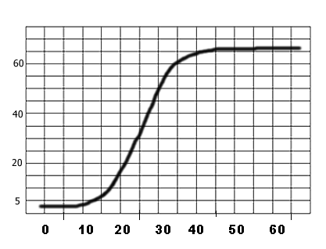
D. 0

12. The graph at right best demonstrates which type of population growth?

A. logistic
B. exponential
C. strategic
D. poor

Questions 13 and 14 refer to the chart below:

Year | Wolves | Deer born | Deer died
2003 | 10 | 30 | 15
2004 | 20 | 20 | 11
2005 | 30 | 16 | 9
2006 | 15 | 10 | 10
2007 | 10 | 17 | 8
2008 | 11 | 20 | 6

13. What is the carrying capacity of deer in this particular population?

A. 30
B. 15
C. 10
D. 0

14. Using the chart to make a prediction, what do you think would happen to the wolf population in the next 5 years?

A. It would decline until the population reached 0.
B. It would increase slowly so long as the deer population continued to increase into 2009.
C. It would rapidly rise until all the deer were gone.
D. None of the above.

15. A tapeworm infection among humans would be considered an example of
- commensalism.
- mutualism.
- parasitism.
- predation.

16. Remora sharks are endowed with an adhesive disk on the dorsal surface of their heads. They use this adhesive disk to “hitch a ride” on larger animals, usually whales, which tend to be sloppy eaters. When food floats away from the whale’s mouth, the remora can unhitch itself and collect the scraps of food floating by.
This example of Remora sharks would best fit which of the following symbiotic relationships?
- commensalism
- mutualism
- parasitism
- predation

17. Although termites can physically chew and ingest wood, they are incapable of chemically digesting cellulose into sugars. They rely on intestinal flagellates, e.g. Pyrrsonympha spp. and Trichonympha spp. which are capable of digesting cellulose into energy-rich sugar. These flagellates reside in the hindgut of termites and provide nutrition for them. They are not found anywhere else in nature.
The example of termites and the flagellate microorganism best fit which symbiotic relationship?
- commensalism
- mutualism
- parasitism
- predation

18. A lake in Minnesota was thriving with black bass and bluegill. These particular fish build nests on the sandy bottom of the lake. Now, ecologists are finding that over time a layer of humus has slowly been covering the pond. The ecologists are noting that the populations of black bass and bluegill are declining, and the fish that are able to make nests in humus are rising in numbers.
The ecologists can probably conclude that this event is an example of:
- commensalism
- parasitism
- primary succession
- succession

19. The fundamental role that an organism plays within its ecosystem would be best described as its
A. niche.
B. fundament.
C. community.
D. habitat.

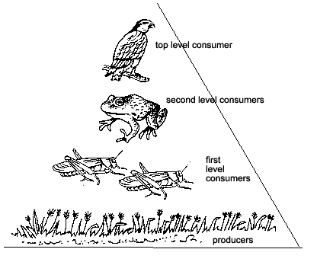
20. There are 10,000 calories per m² present found in the producer level. Given that information, how many calories may be found in the first level consumers?

A. 10 calories/ m²
B. 100 calories/ m2
C. 1,000 calories/ m²
D. 10,000 calories/ m²

For numbers 21-25, match each term with the correct definition.
21. Biodiversity A. The living factors that can affect an ecosystem.
22. Abiotic factors B. The nonliving factors that can affect an ecosystem.
23. Habitat C. The place where an organism or population lives.
24. Biotic factor D. The number of species living in an ecosystem.
25. Community E. The many different species that live together within an ecosystem.
For numbers 26-29, match each term with the correct definition.
26. Food Web A. The study of the interaction of organisms with each other and with
their environment.
27. Ecosystem
B. A community plus abiotic factors.
28. Ecology
C. An interconnected map of food chains.
29. Primary productivity
D. The rate at which plants produce sugars from the sun.

30. A simple food web is shown below:
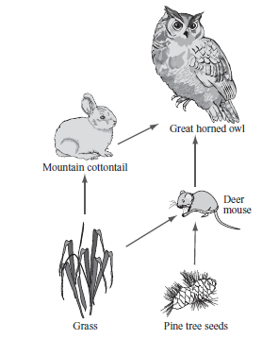
Which of the following is most likely to lead to the greatest decrease in the deer mouse population?
A. An increase in the owl population.
B. An increase in the grass population.
C. An increase in the pine tree population.
D. An increase in the cottontail population.

31. Which of the following best describes the process in which plants use their roots to absorb nitrogen in the soil?
A. Erosion.
B. Respiration.
C. Transpiration.
D. Assimilation.

32. One way that water is returned to the atmosphere during the water cycle is through a process known as ________.
A. Transpiration
B. Evaporation
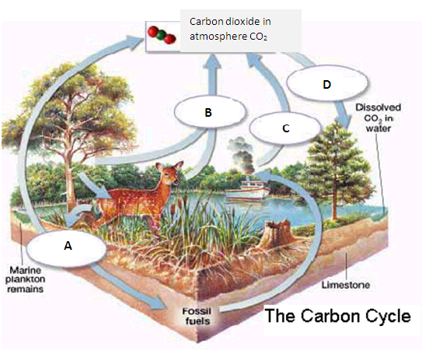
C. Condensation
D. Both (a) and (b)

Questions 33-35 refer to the figure at right:

For numbers 33-35 match the term with the letter in the diagram.

33. Photosynthesis

34. Combustion

35. Respiration

36. The potential resources and area that an organism can possibly use is known as its

- Realized niche.
- Fundamental niche.
- Dispersion pattern.
- Population growth.

37. Cane Toads are native to Hawaii, but were introduced to Australia in the 1930’s. They had no natural predators and bred rapidly. They are currently a problem and have significantly disrupted the Australian ecosystems. Cane Toads are best described as:

- Parasites.
- Mutualists.
- Commensalists.
- Invasive.

38. The back and forth evolutionary adjustments between two or more species is known as ______________.

- Commensalism.
- Mutualism.
- Coevolution.
- Fundamental niche.

39. Biogeochemical cycles are the cycling of elements/molecules between ___________ and ____________ factors.

- living; nonliving
- bacteria; soil
- plants; atmosphere
- water; carbon

40. List the following in order from SMALLEST to BIGGEST:
Biome, community, ecosystem, biosphere, population

- Population, ecosystem, community, biosphere, biome.
- Biosphere, biome, population, community, ecosystem.
- Biome, biosphere, community, ecosystem, population.
- Population, community, ecosystem, biome, biosphere.

OPEN RESPONSE- Please complete on a separate piece of paper
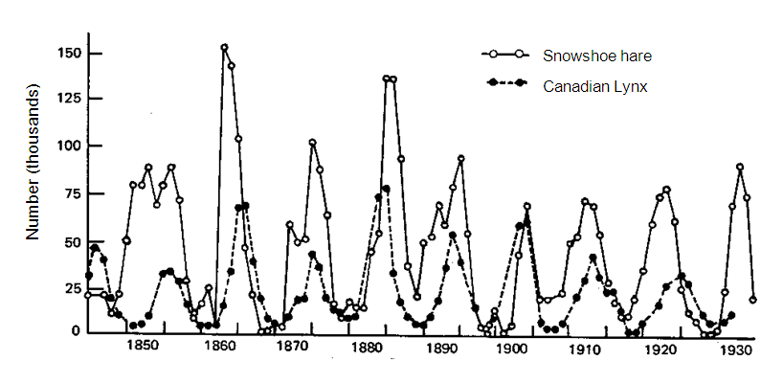
Use the graph to answer the following questions in complete sentences.
A) What are the approximate carrying capacities of the lynx and hare populations?
B) Give one possible explanation for the decline of the hare population in 1848.

- Give one possible explanation for the decline of the lynx population that took place near 1905.

D) Compare the predator-prey relationship of the lynx-hare graph above to the moose and wolf predator-prey relationships depicted below.

